NAME: SANKET MEKWAN & AKSHAY GOHEL

ID NO: 20CP012 & 20CP004

BATCH : A

SUBJECT: WEB TECHNOLOGY

PROJECT TITLE:- CINEMA WEBSITE

PROJECT DESCRIPTION: -

This project is related to Cinema Website which consist of different theaters. In this, user can create account , login in to that particular account . one can get the information that which movie is currently screening in the cinema and also know about upcoming movies . Customer can get the information about the movie show timing and can book the tickets . There is also an option available as review where use can share their opinion about the movies.

Languages used for this Project:

* HTML for static pages.
* CSS for styling purpose.
* JavaScript for adding dynamic content and Validation of the data.
* PHP and MySQL for store the data in backend.

Features:

* Home Page
* Contact us
* About us
* Acc for creating an account.
* Login form
* Review
* Book the Show

Er diagram:

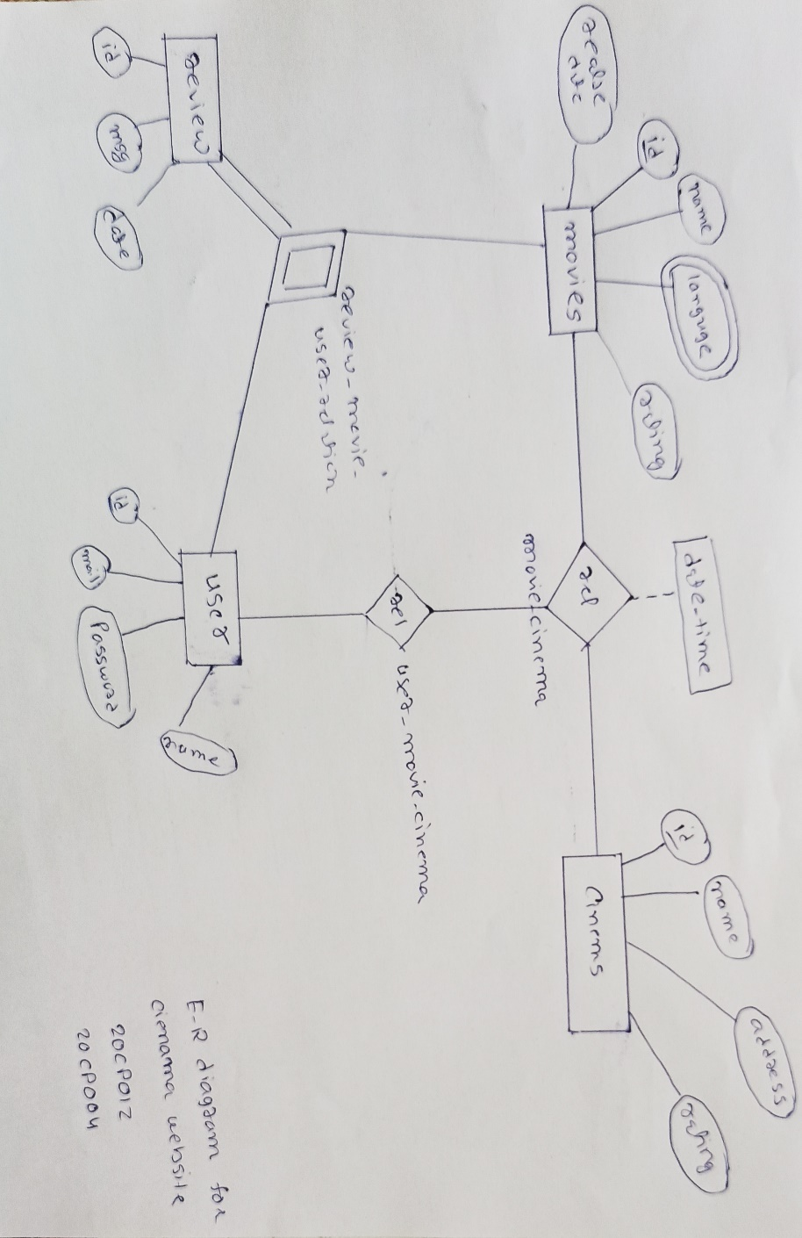

Mysql schema:

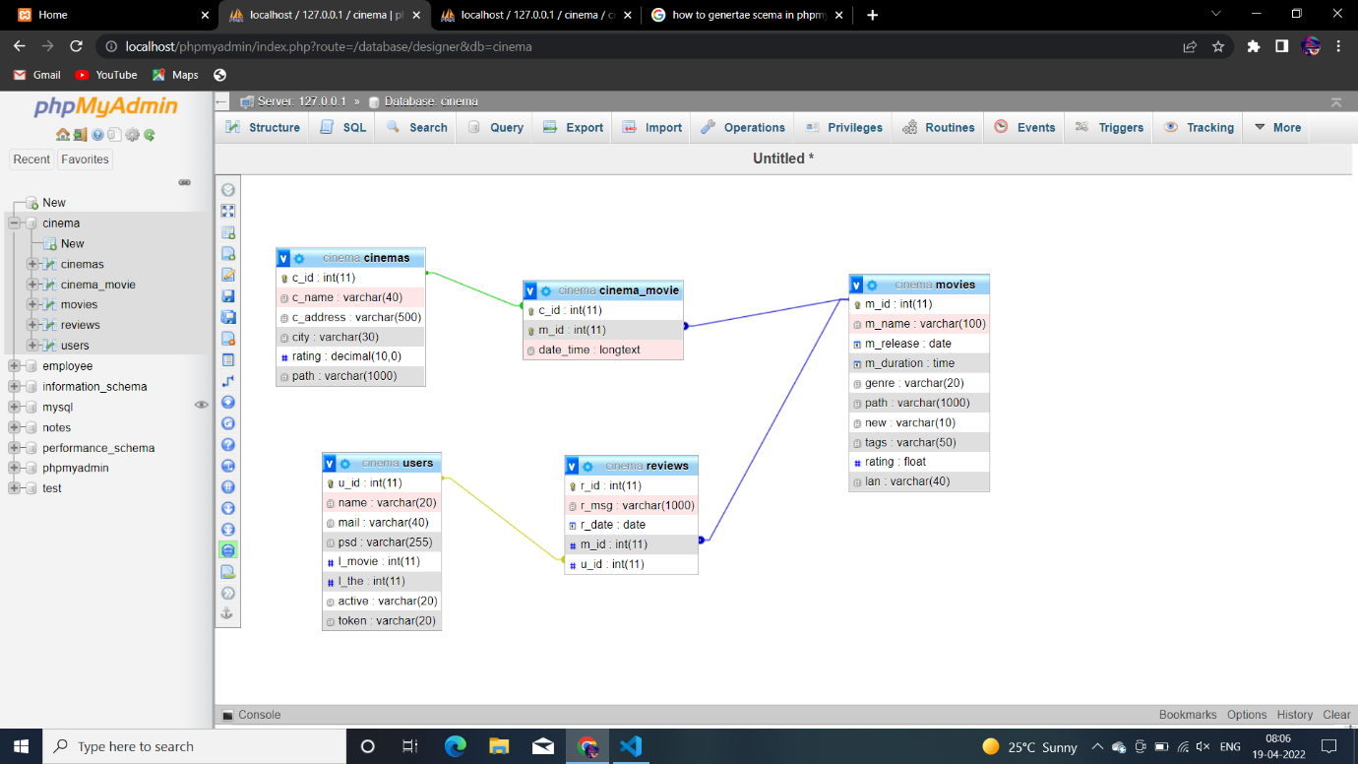

Mysql tables ss:

1. All tables:

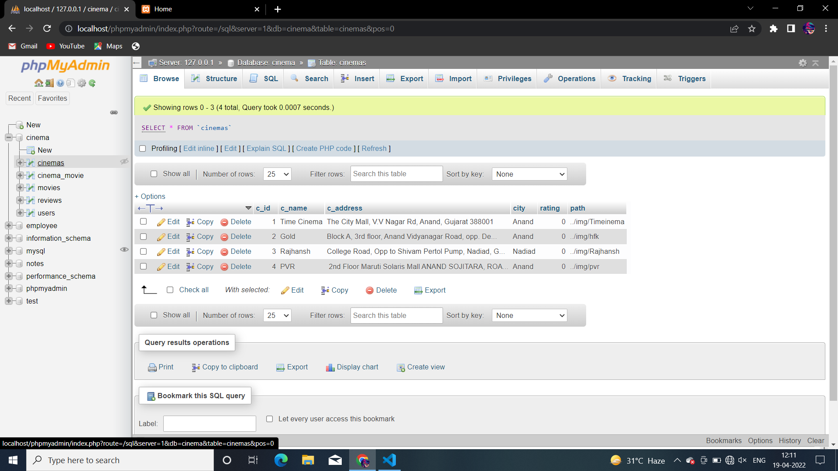

1. User table:(for authentication)

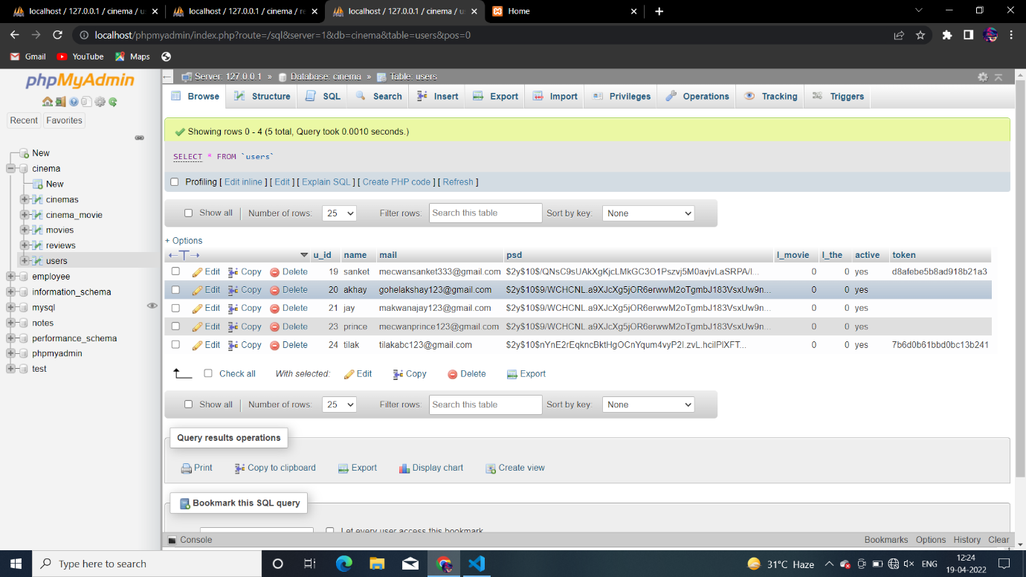

1. Movie table : (to store information about movie)

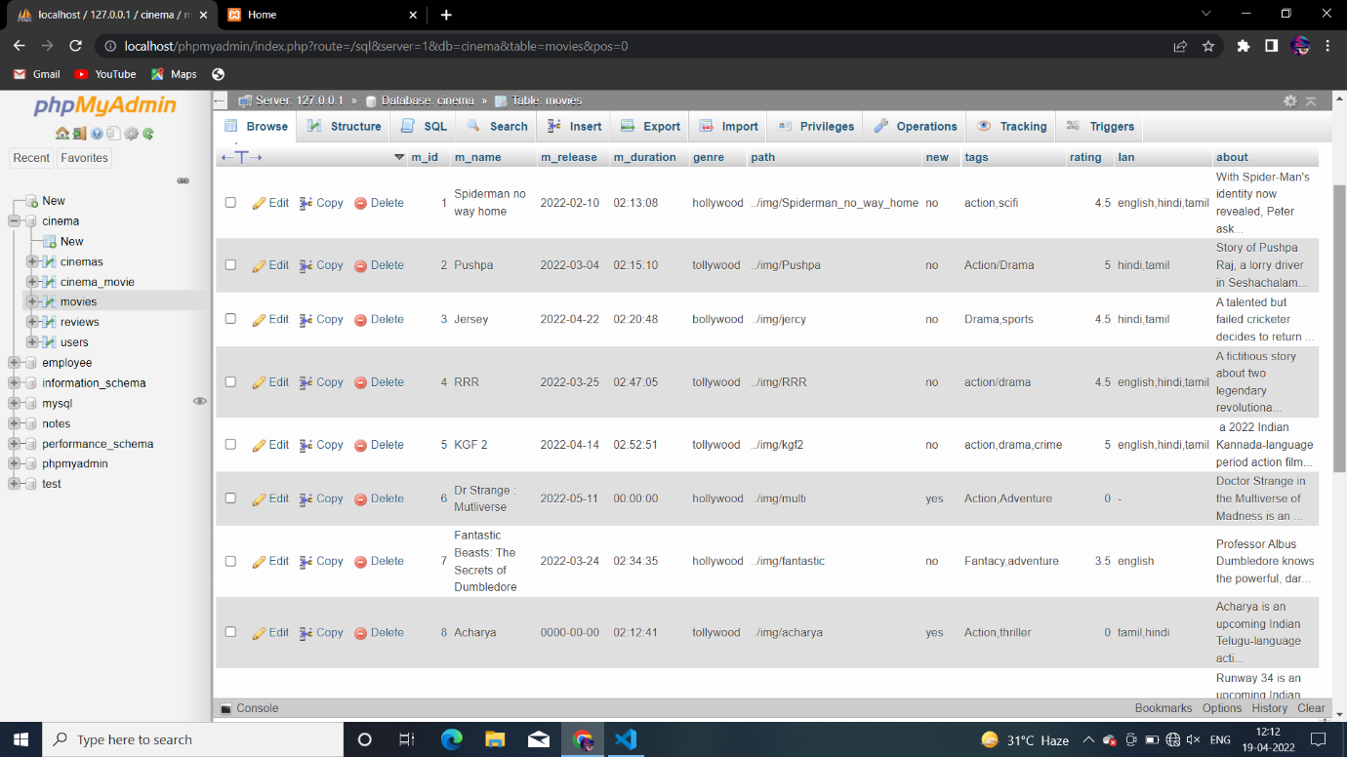

1. Cinema table: (to store details about cinema)

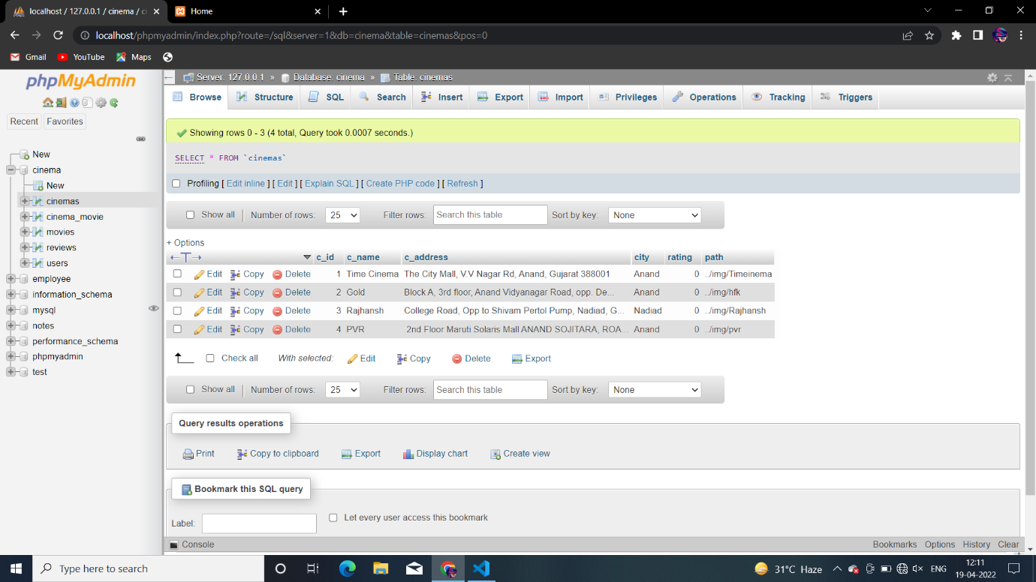

1. Relationship table between cinema and movie

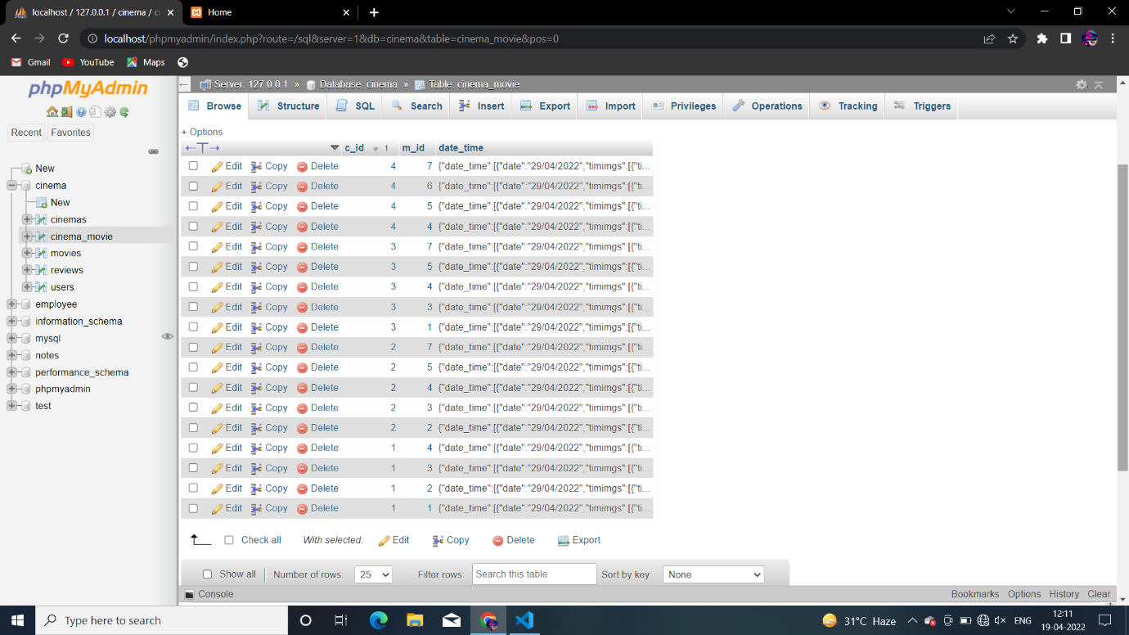

1. Review table:

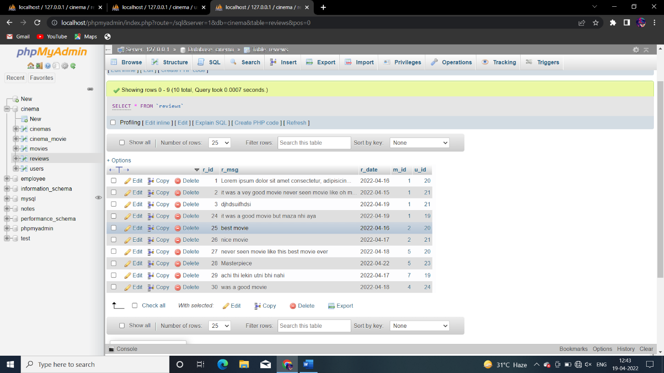

Webpages ss with explanation:

1. Homepage: here user can see different movie as well as cinema at the top what is tranding going on will be shown;like..

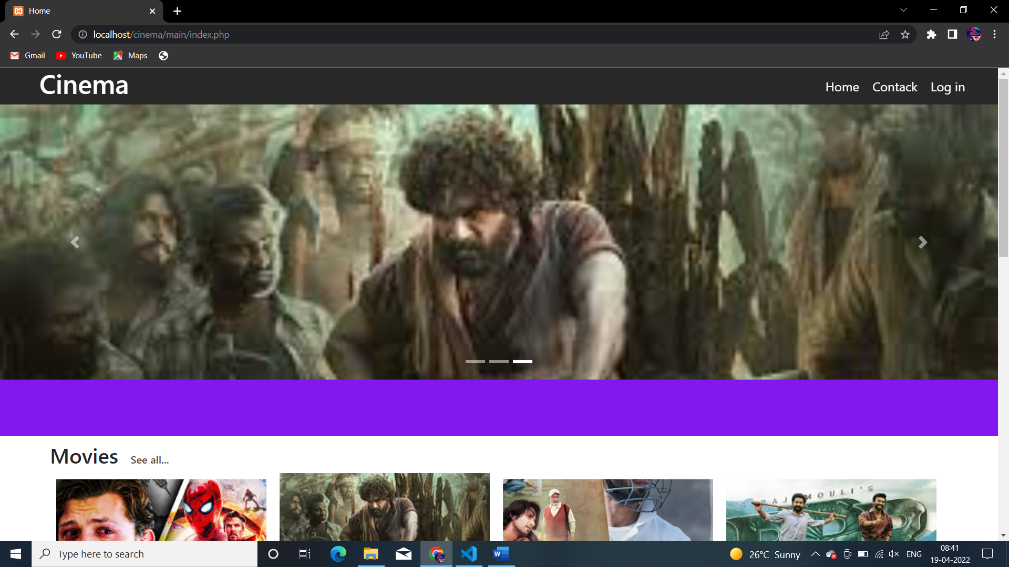

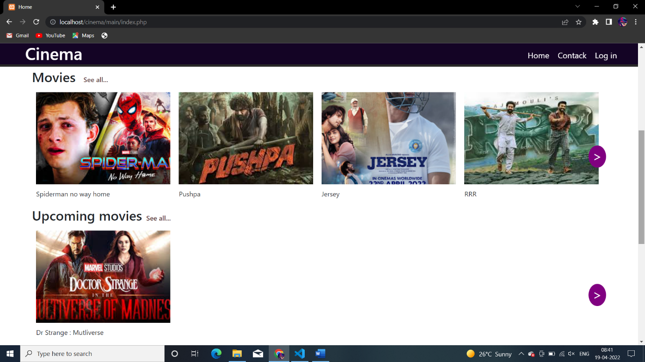

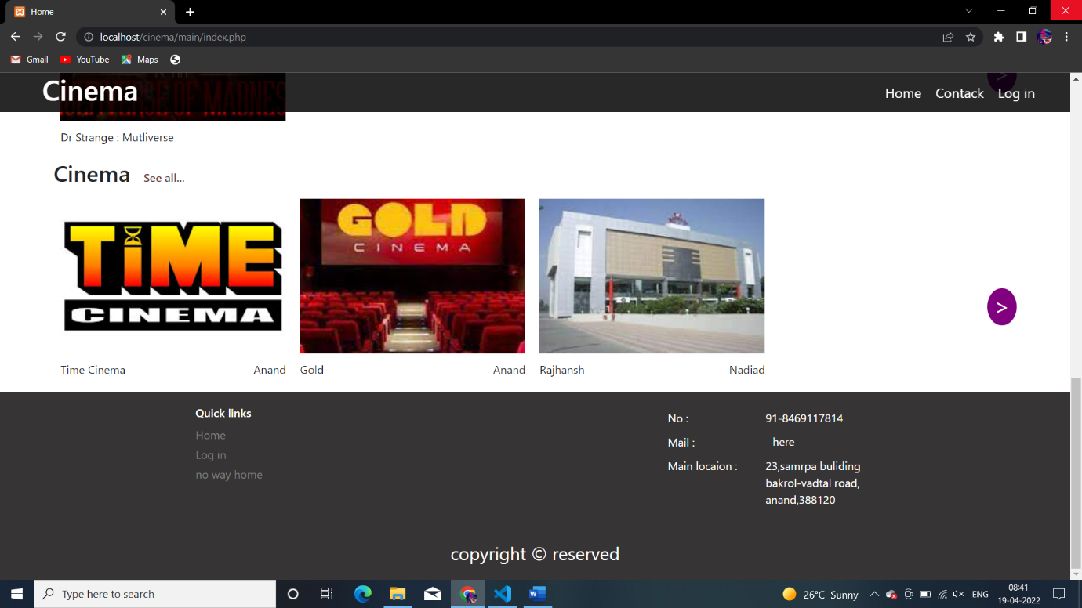

It is also responsive like.

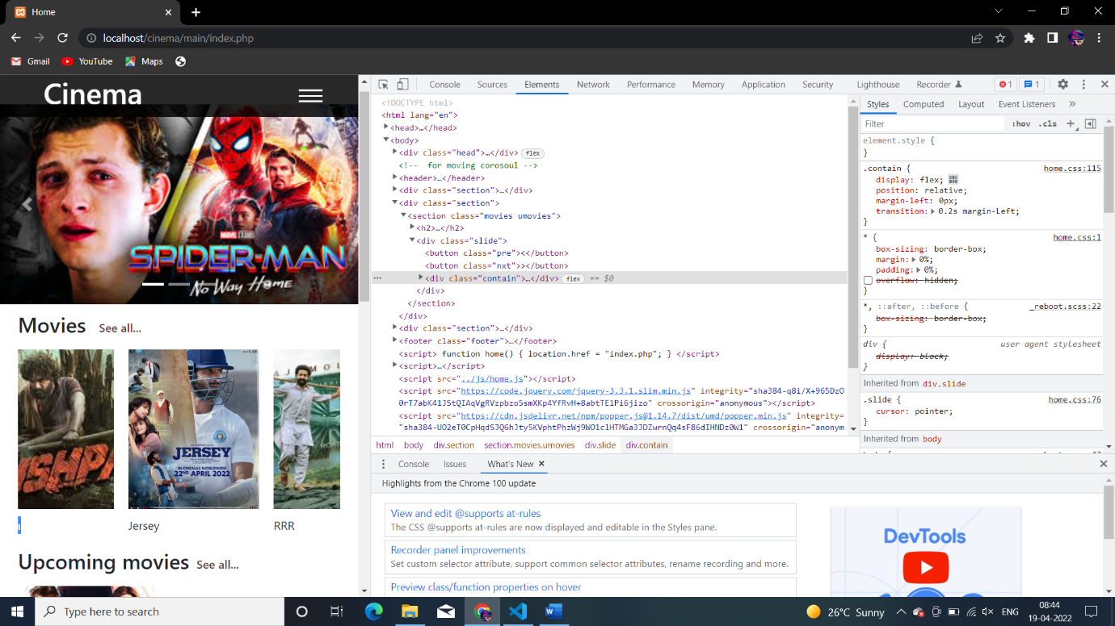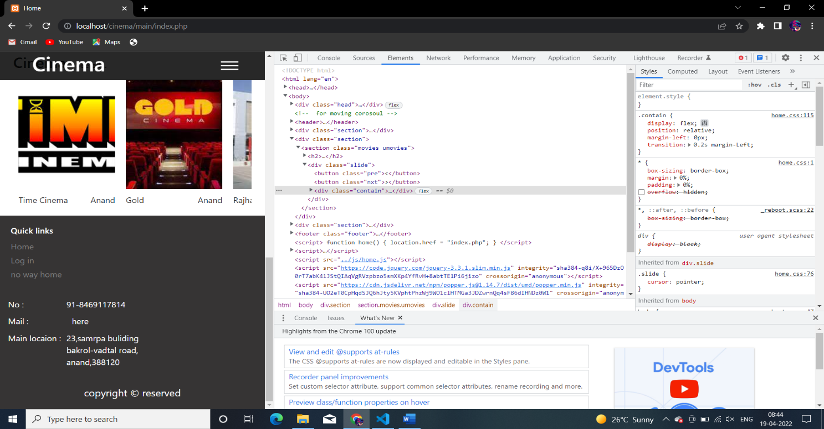

1. Movie page: if in the home page user click any movie then corresponding movie page will be open dynamically by fetching data from the database . in this page use can see reviews or also he can add also by creating first account 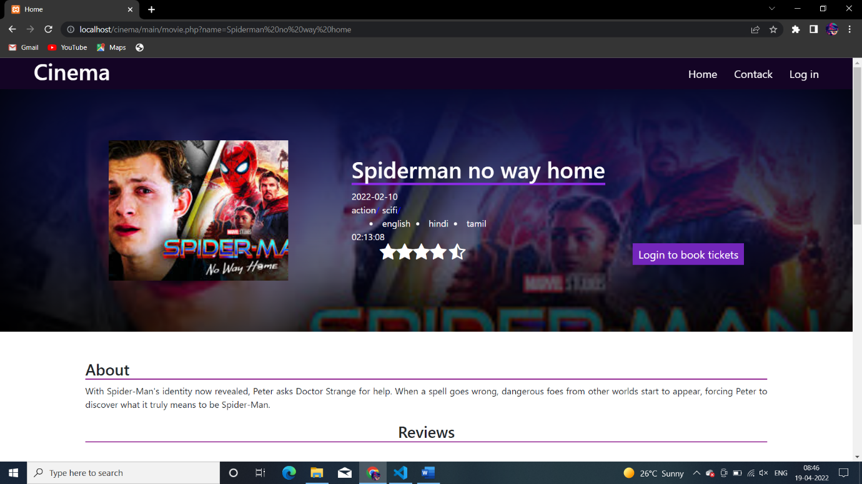

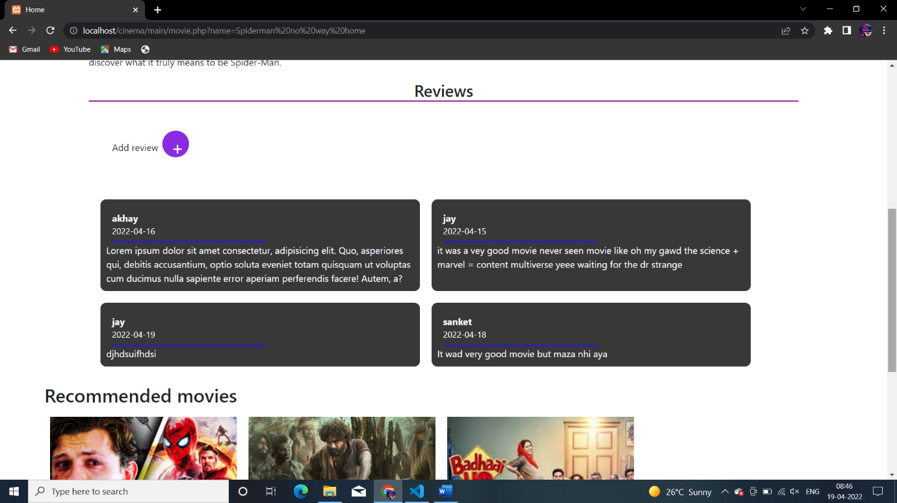

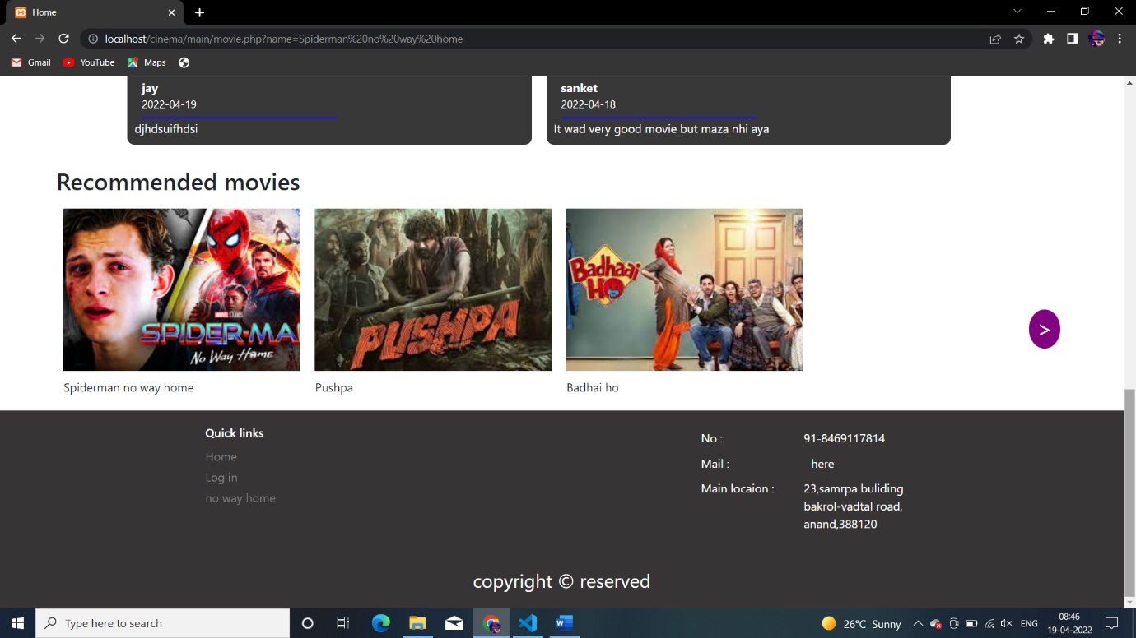

Responsiveness:

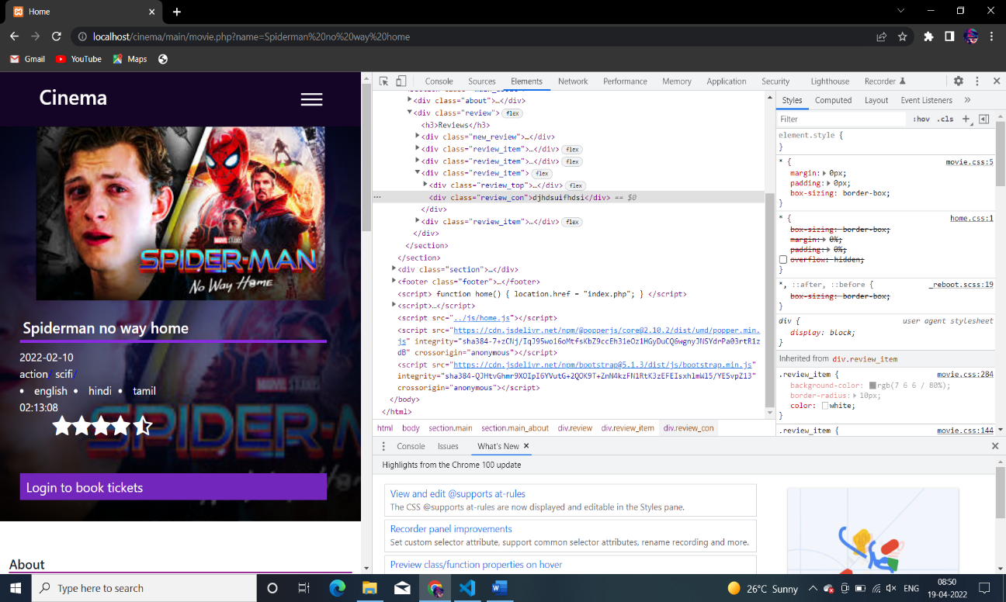 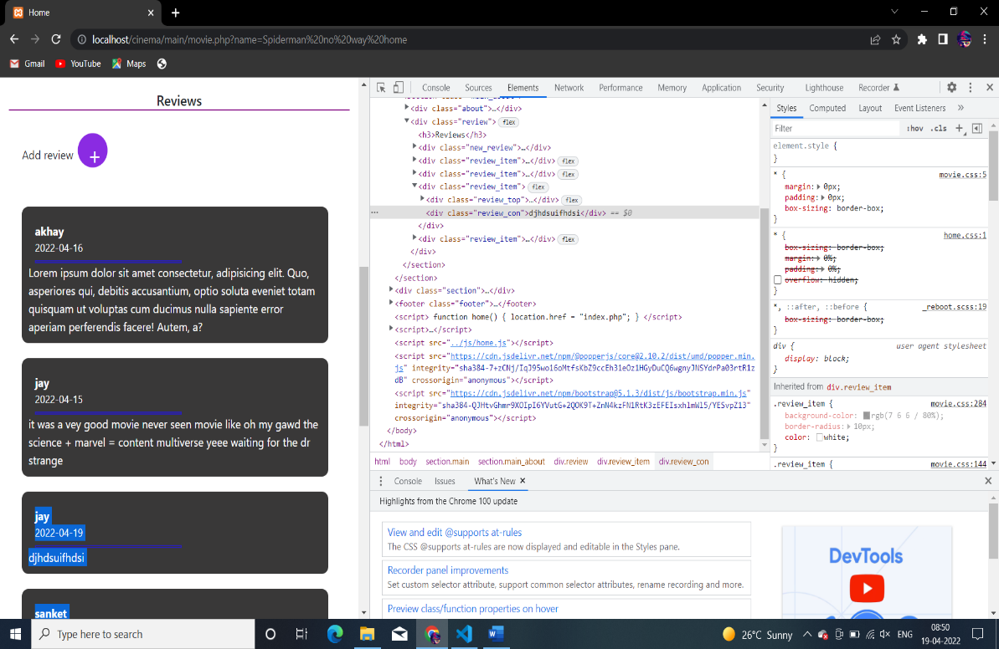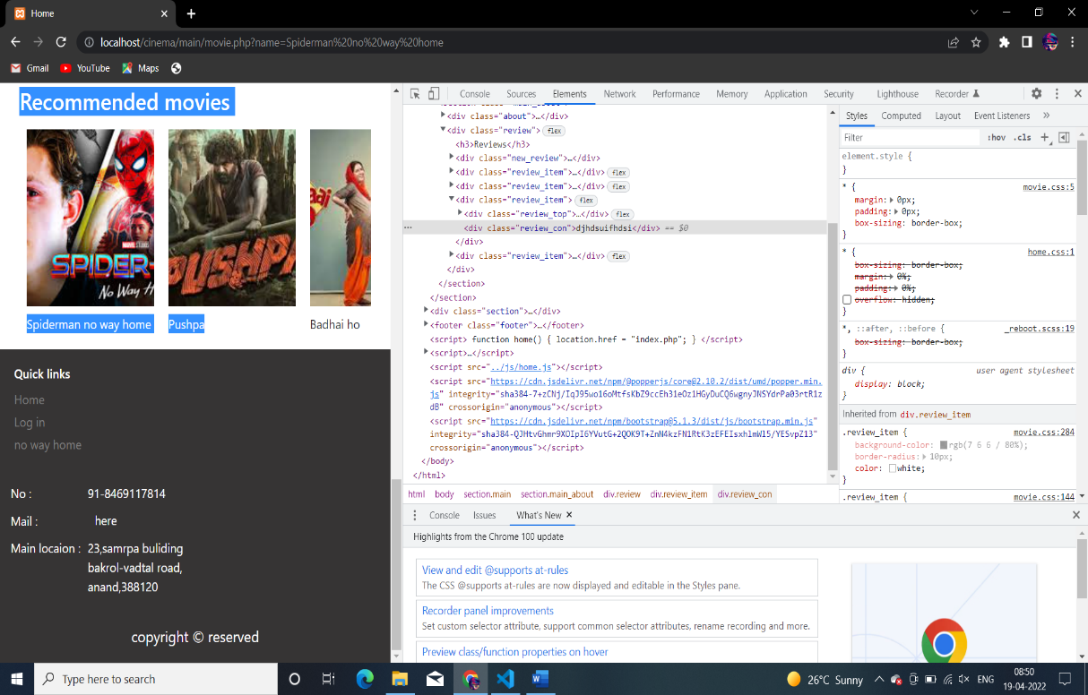

1. Login/signin page : before adding any review or before any ticket booking user must be loged in our website.

So for that this signin pages and login page is there with javascript form validation to valid the data.all the data submitted by user will be saved in database.and here once a user login session will be created now user can add review and book tickets

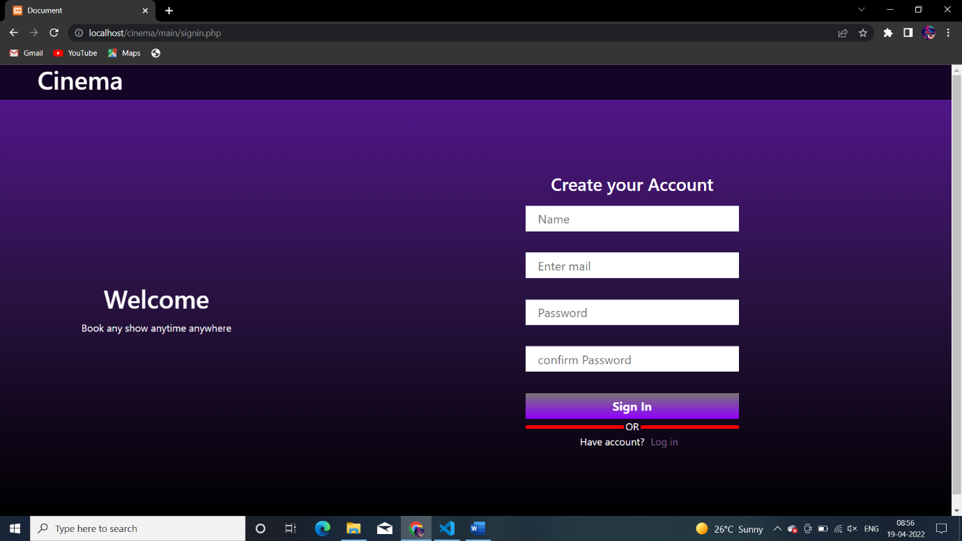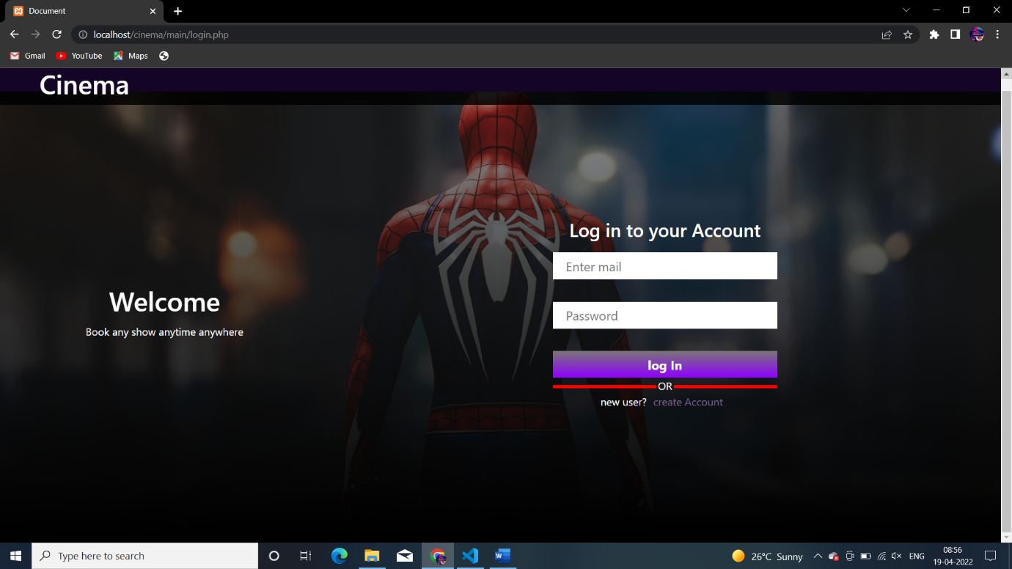

If in user signin data is not valid then javascript validation will work like..

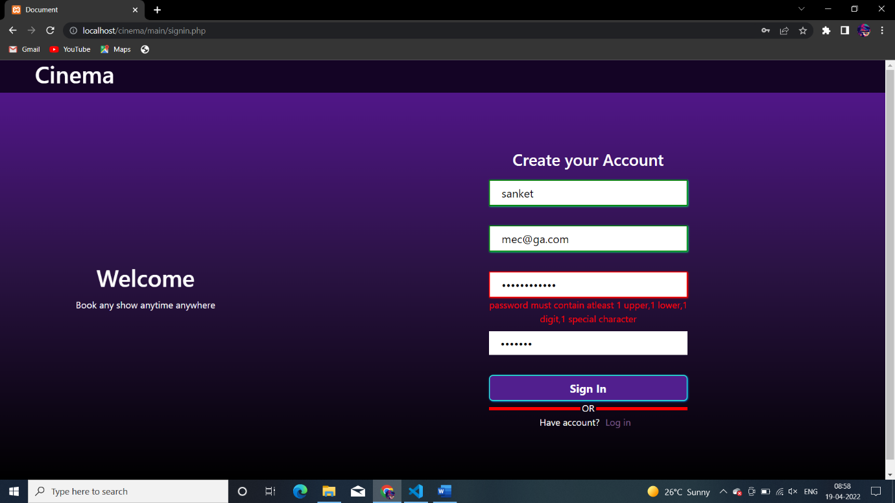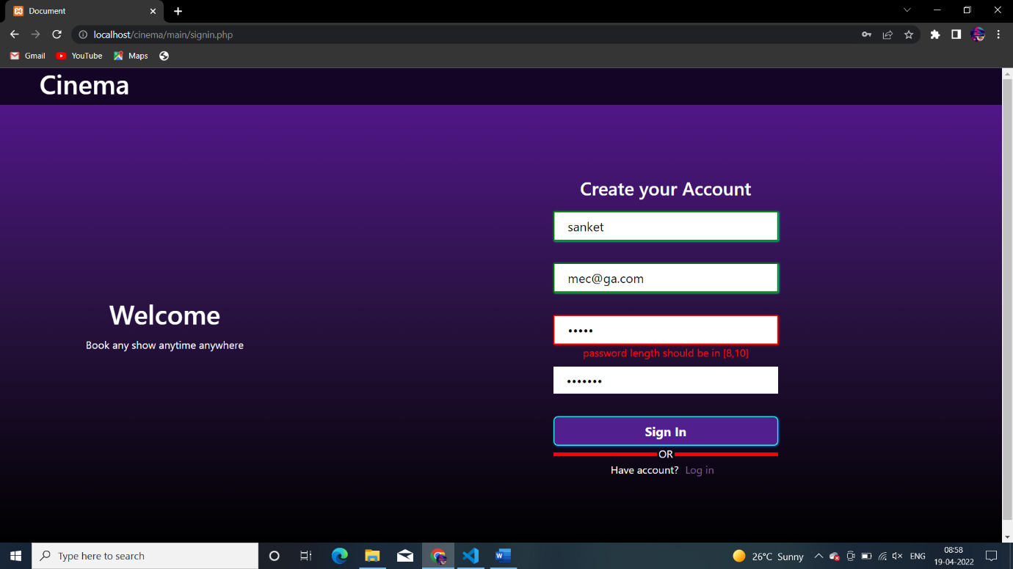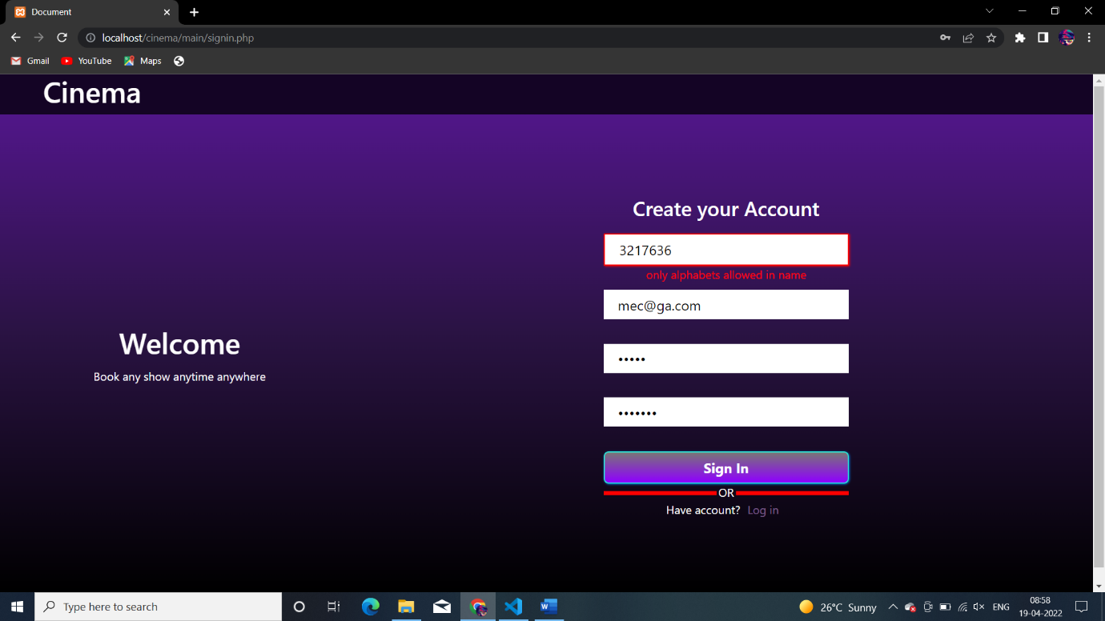

1. Book_ticket page: once a user login he can book ticket by clicking book tickets;

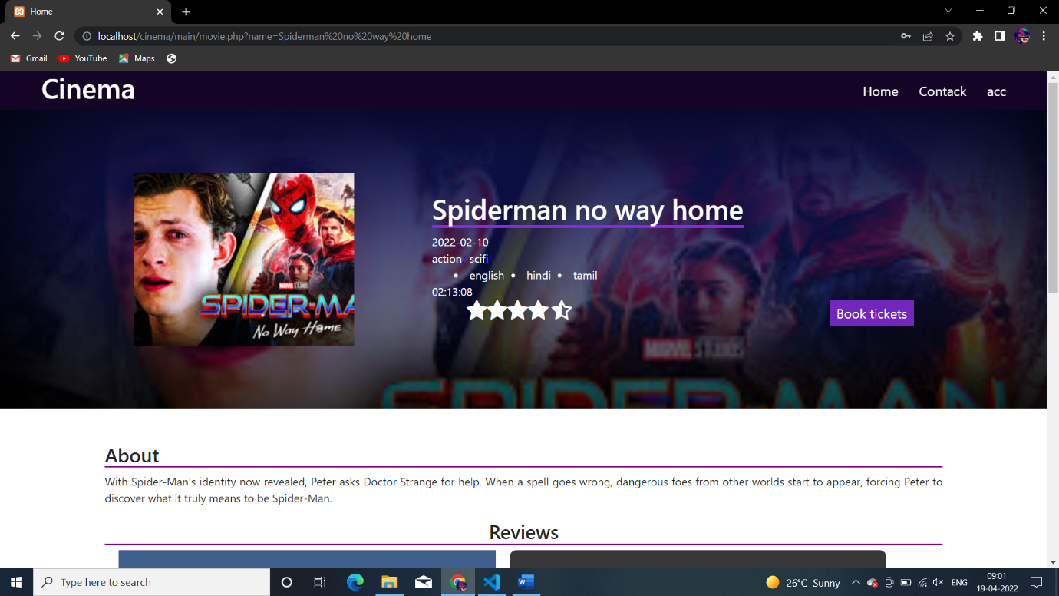

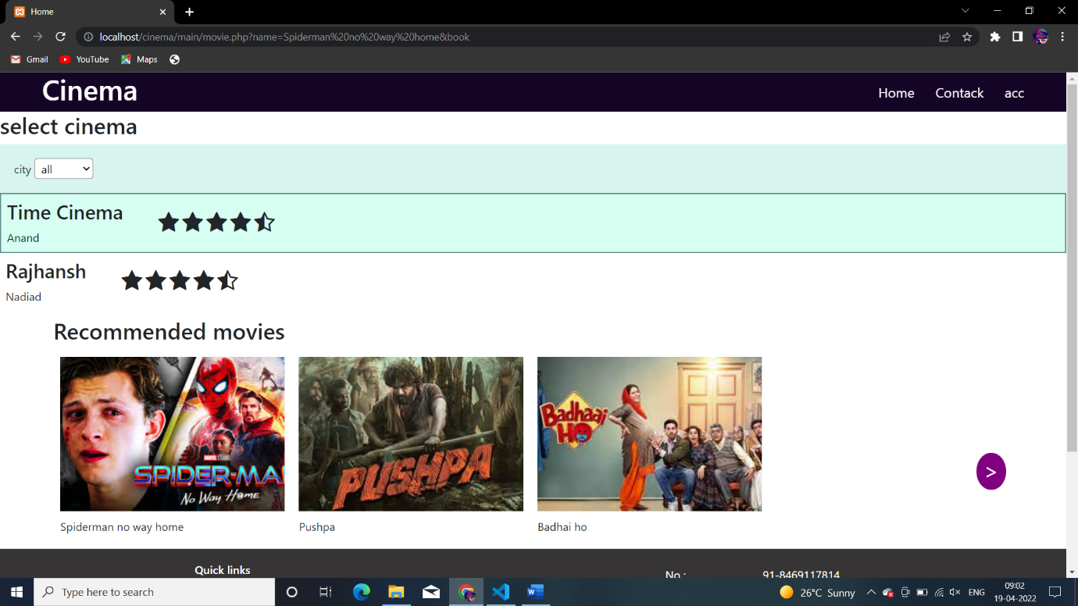

Now cinema has to be chosen

After choose;

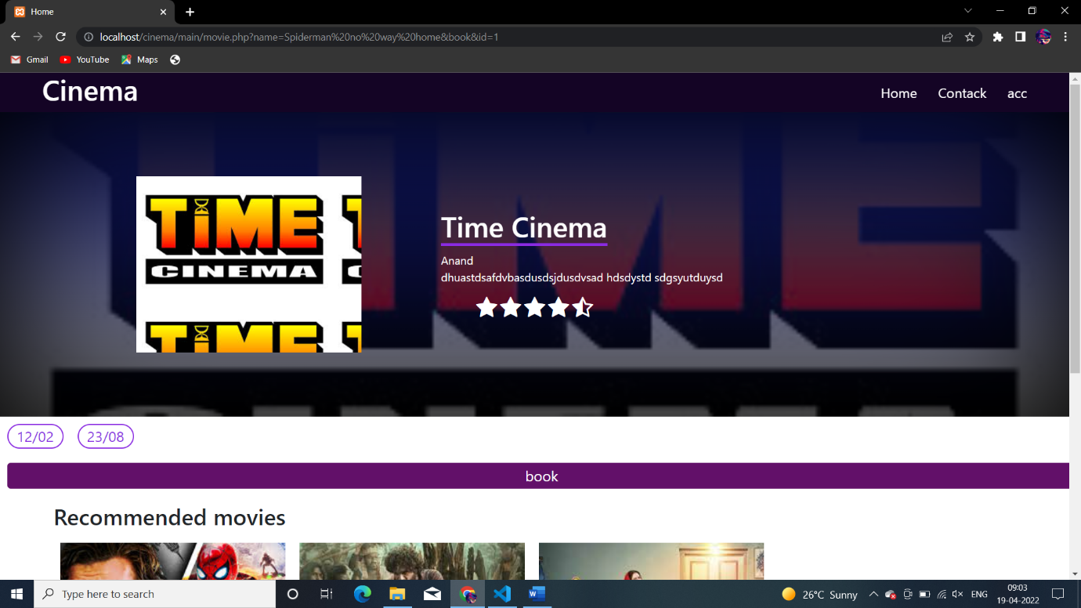

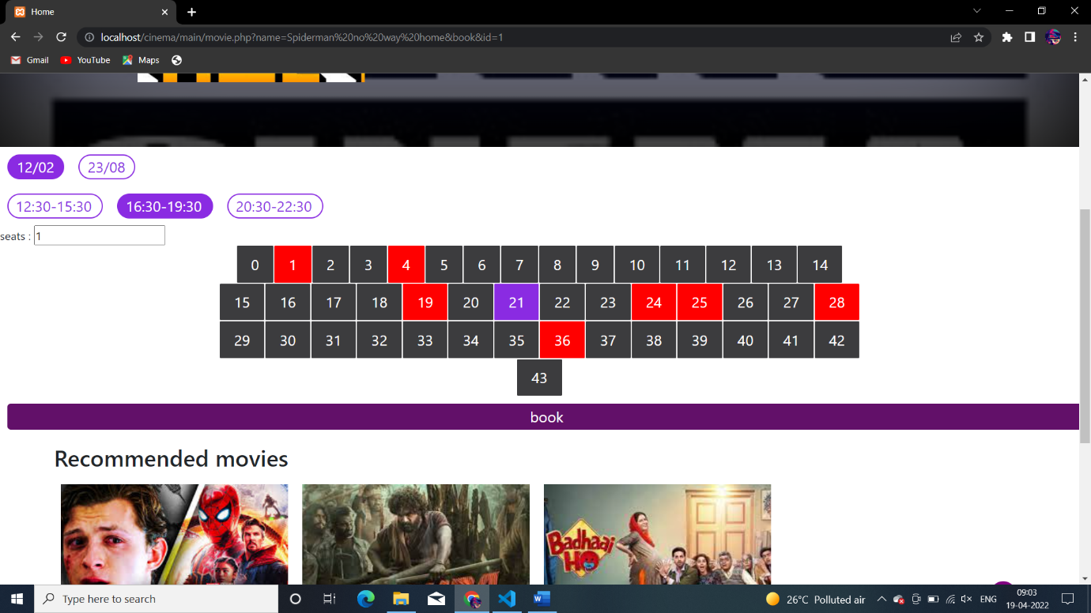

So here user have to select date timing and seats if here 21 is choose and submitted then 21 will be updated as booked seat in database and now if again any user came to this page then 21 will be red;

Like

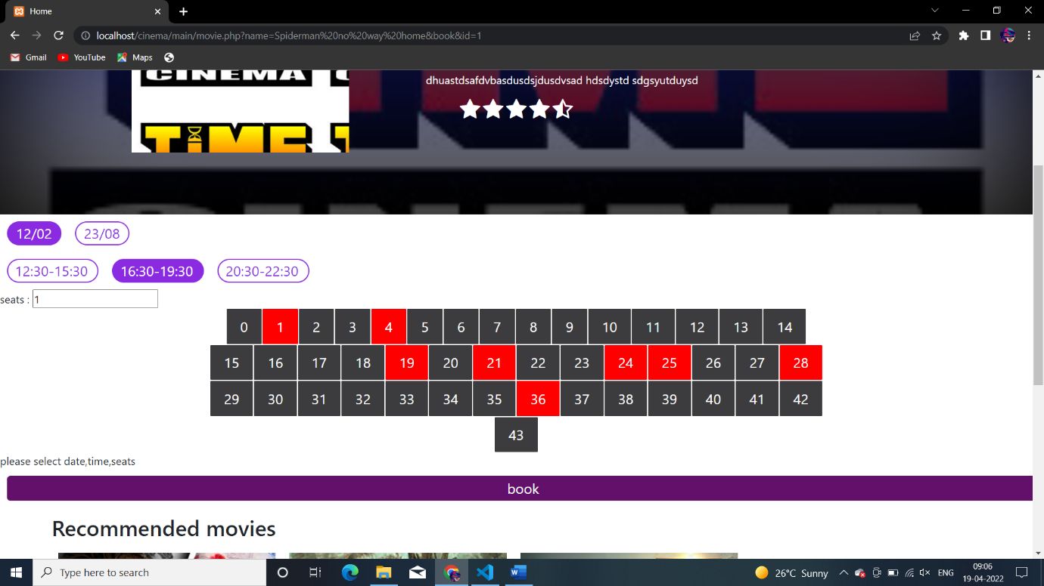

Here point to be noted that all the dates and timing and seats are coming from the database so it is completely dynamic;

1. Review system:

If a user wants to add,update,delete his/her review than he/she can like;

Deleting : 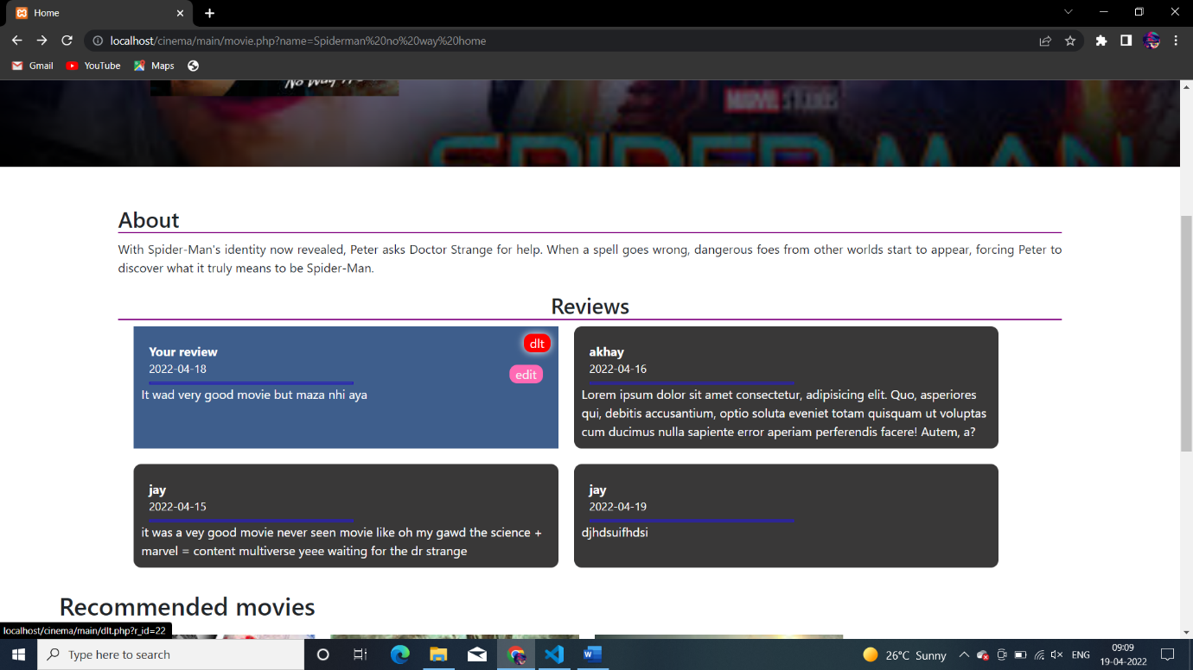

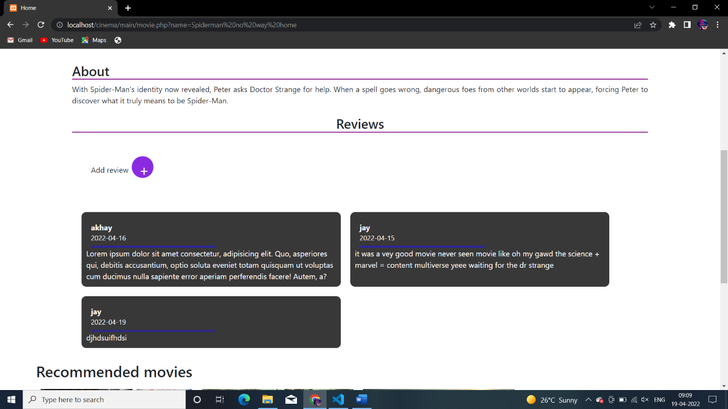

Adding :

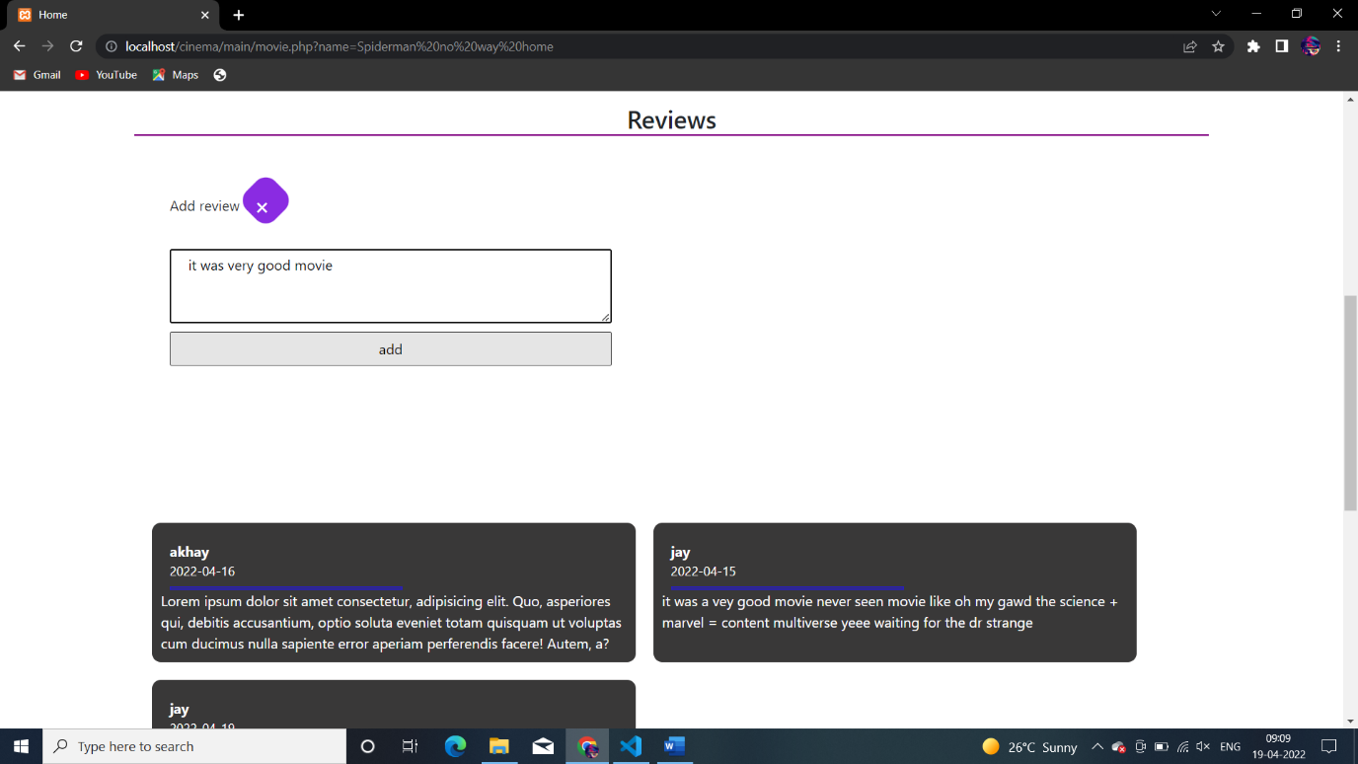

Updating :

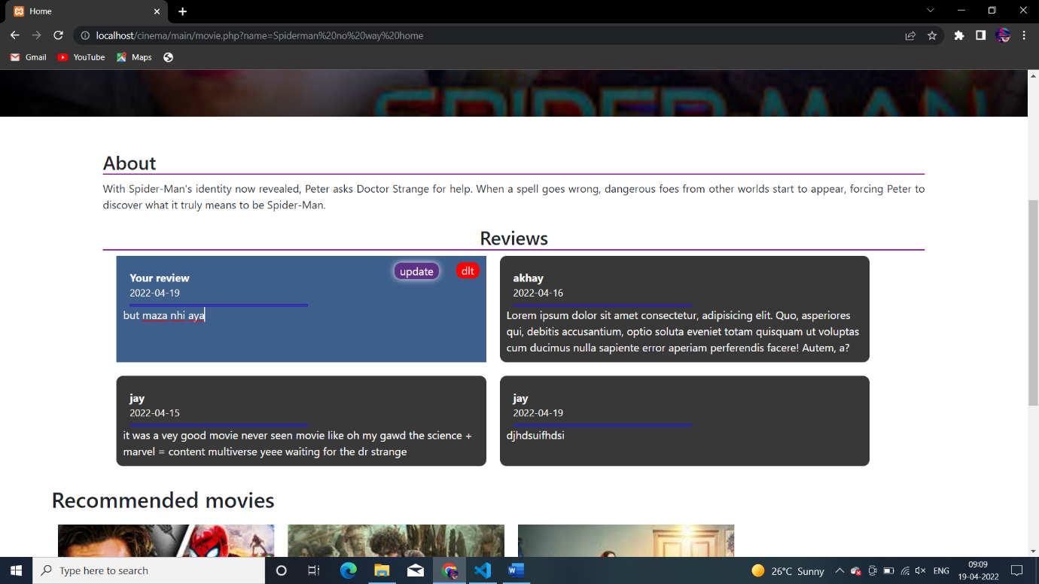

1. Same as movie cinema can also have its page call cinema.php whenever in home page user click any cinema this page will be open and dynamic content will be loaded. And here whichever movie available in this cinema will be shown like
2. 